1.
Go to leads
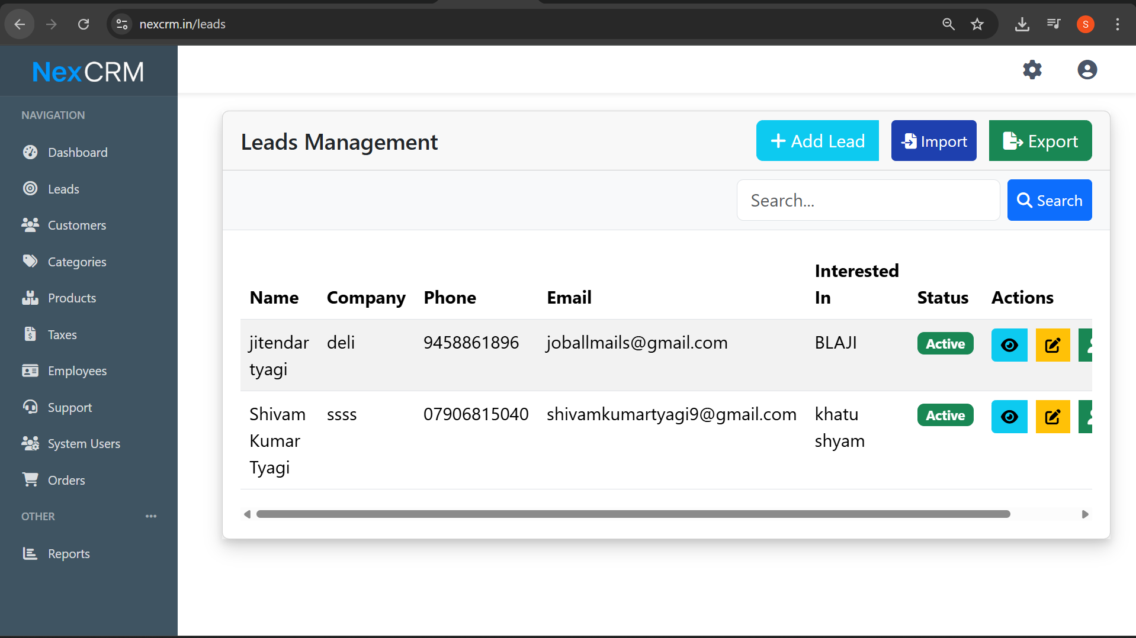

2. click on add leads
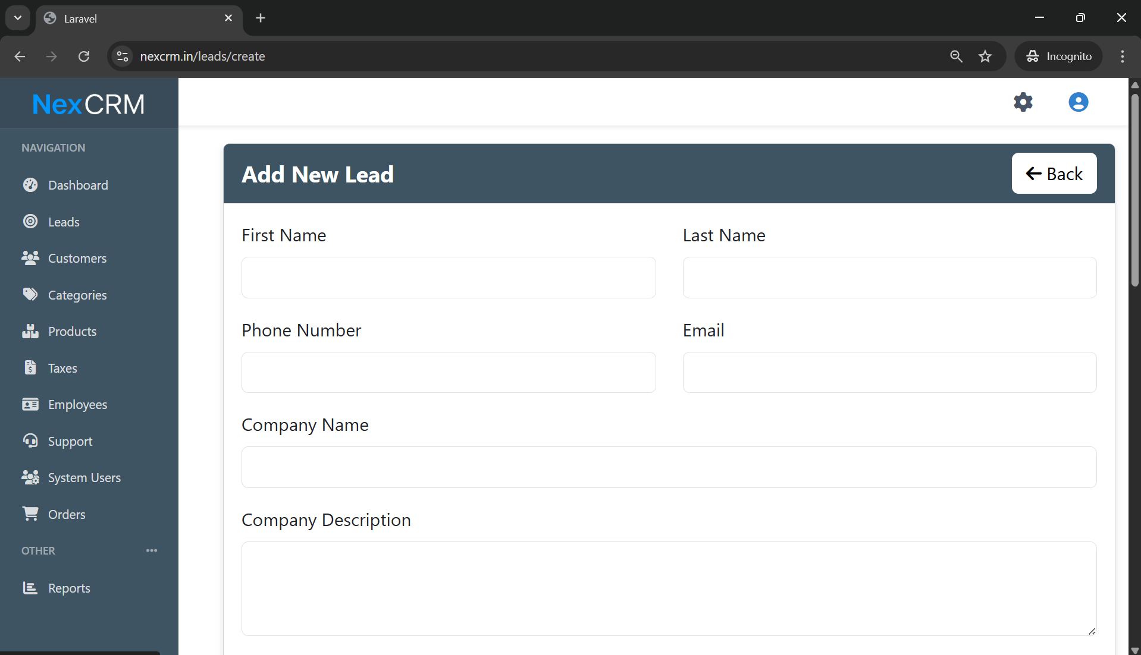

Tester comments: when we click on add leads then this page appears.

3.
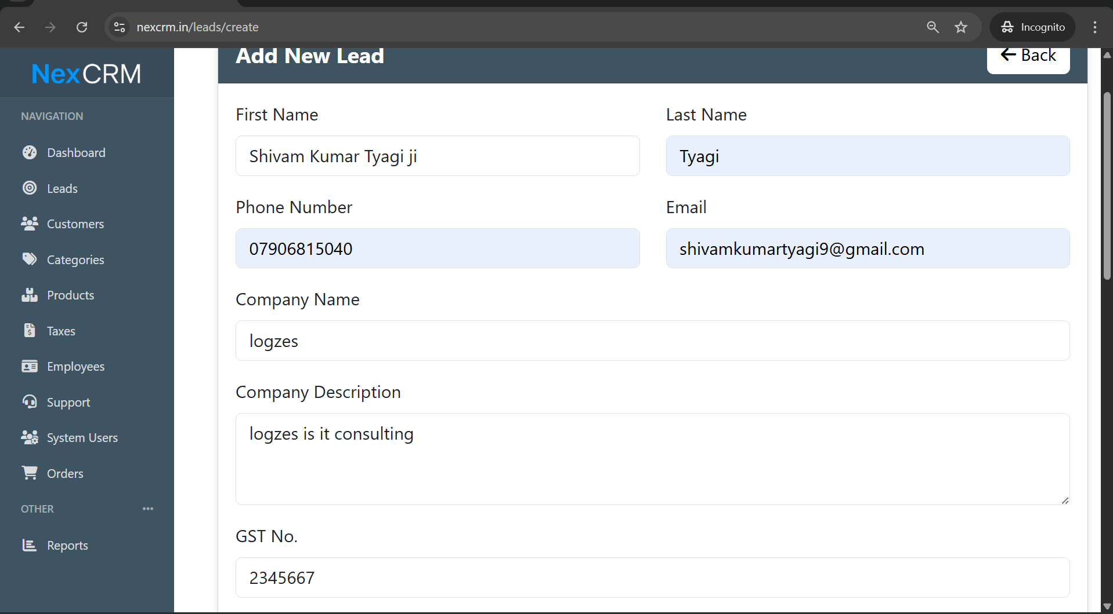
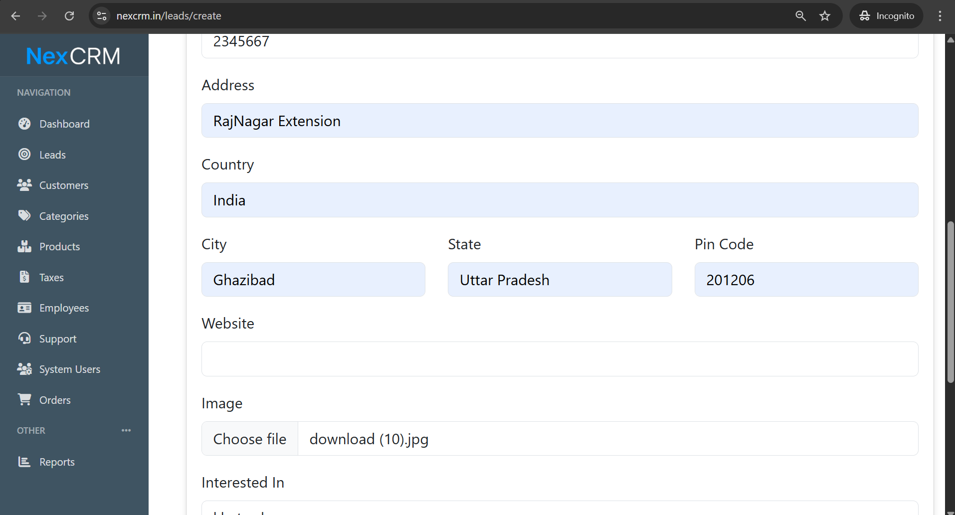
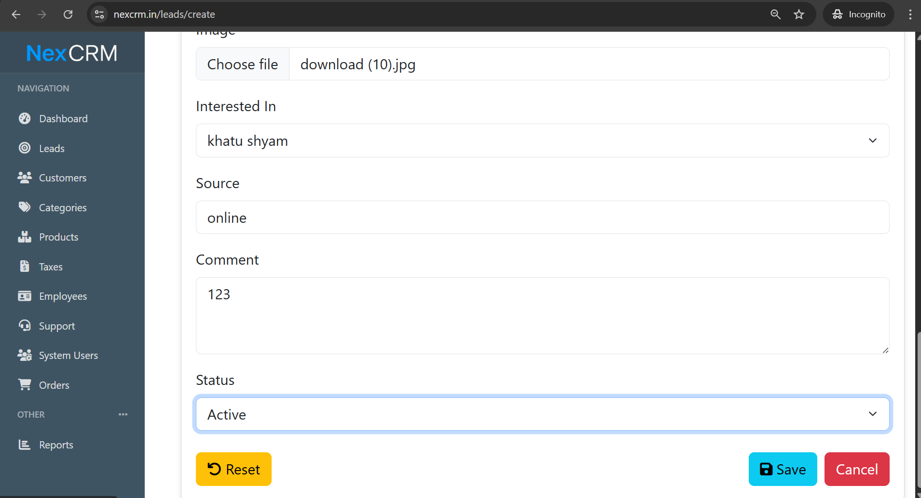

Output
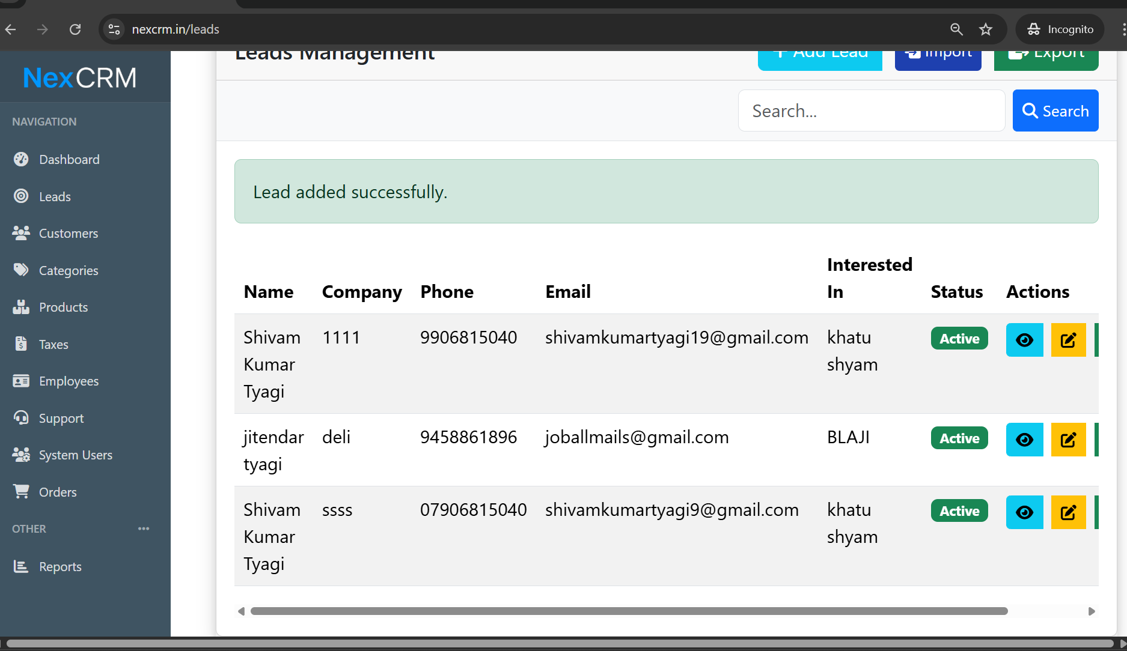
As we see ;lead suucefully added

3.
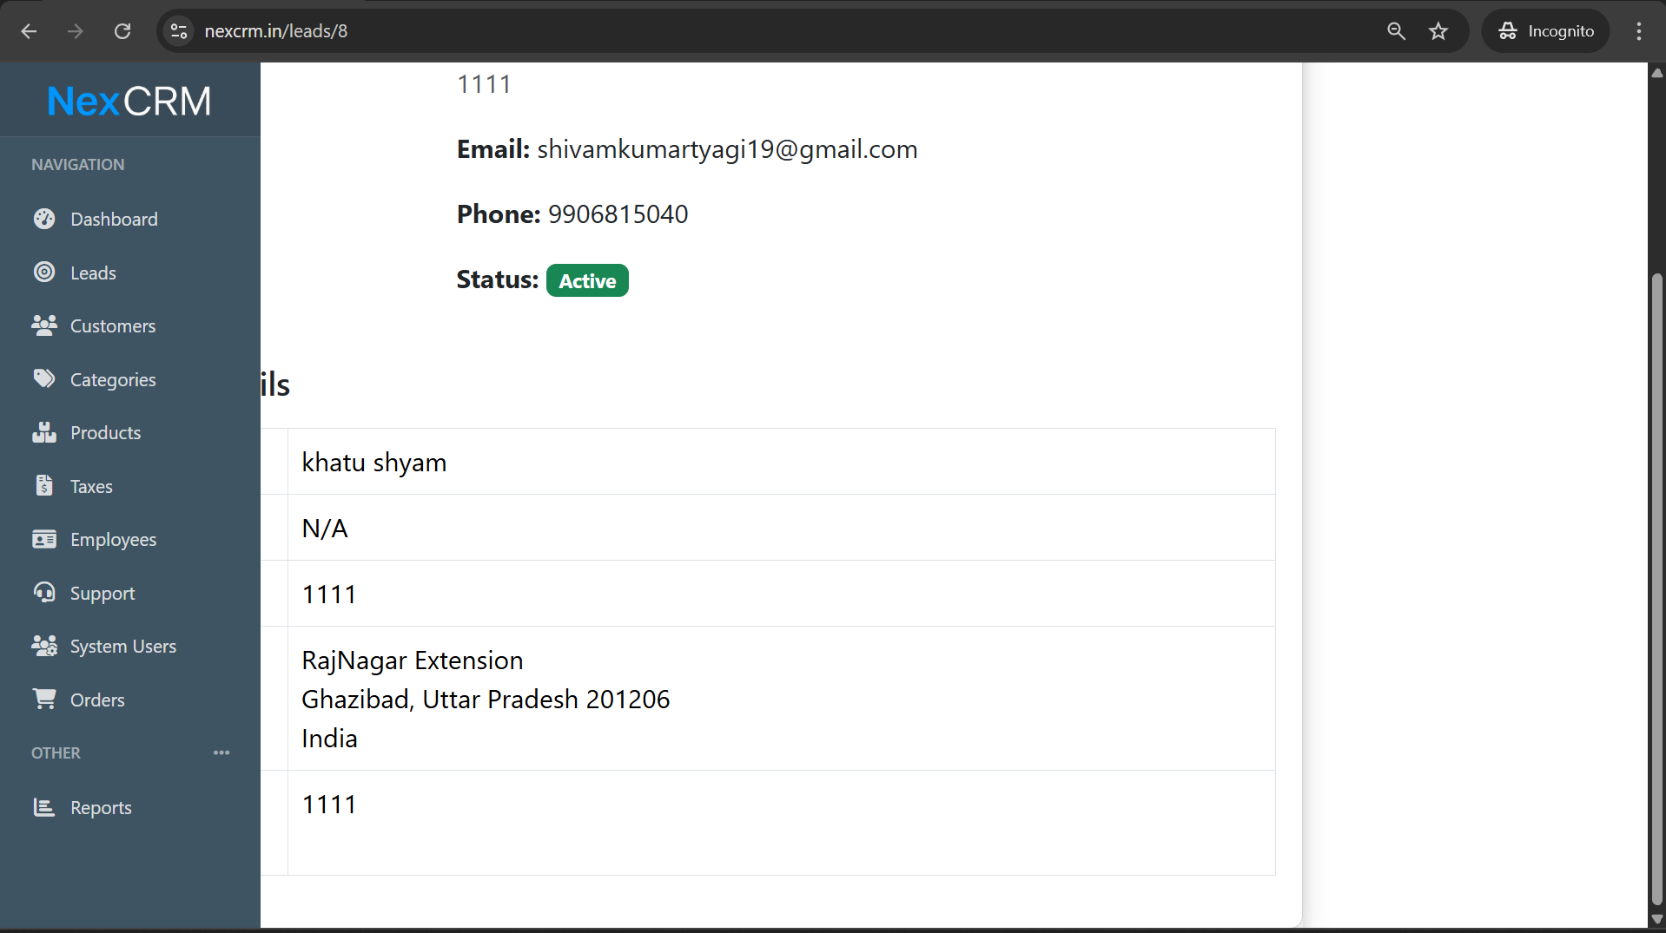

Tester comments ; when we click on view and then this happen the lead ui is not proper vivible .

4.
Now convert lead into costumer
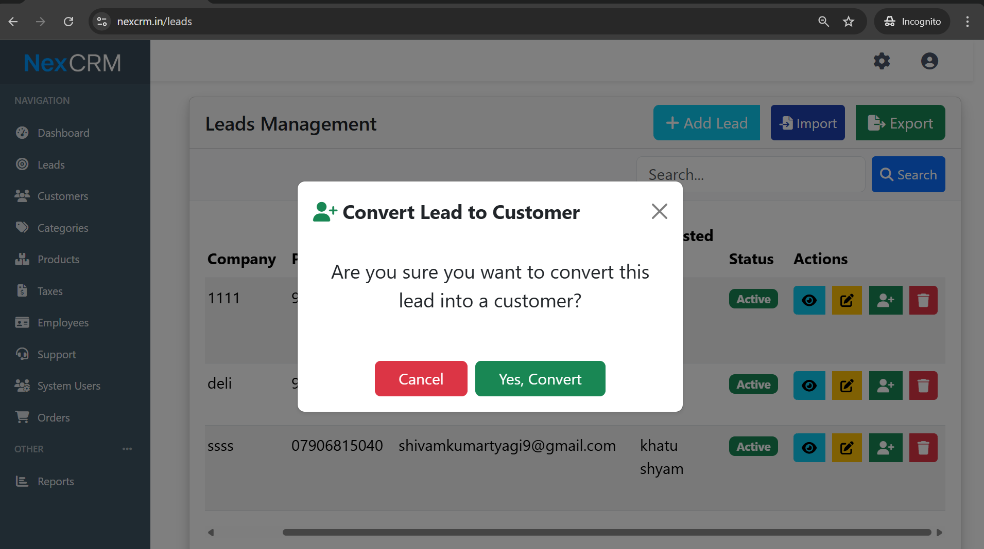

5.
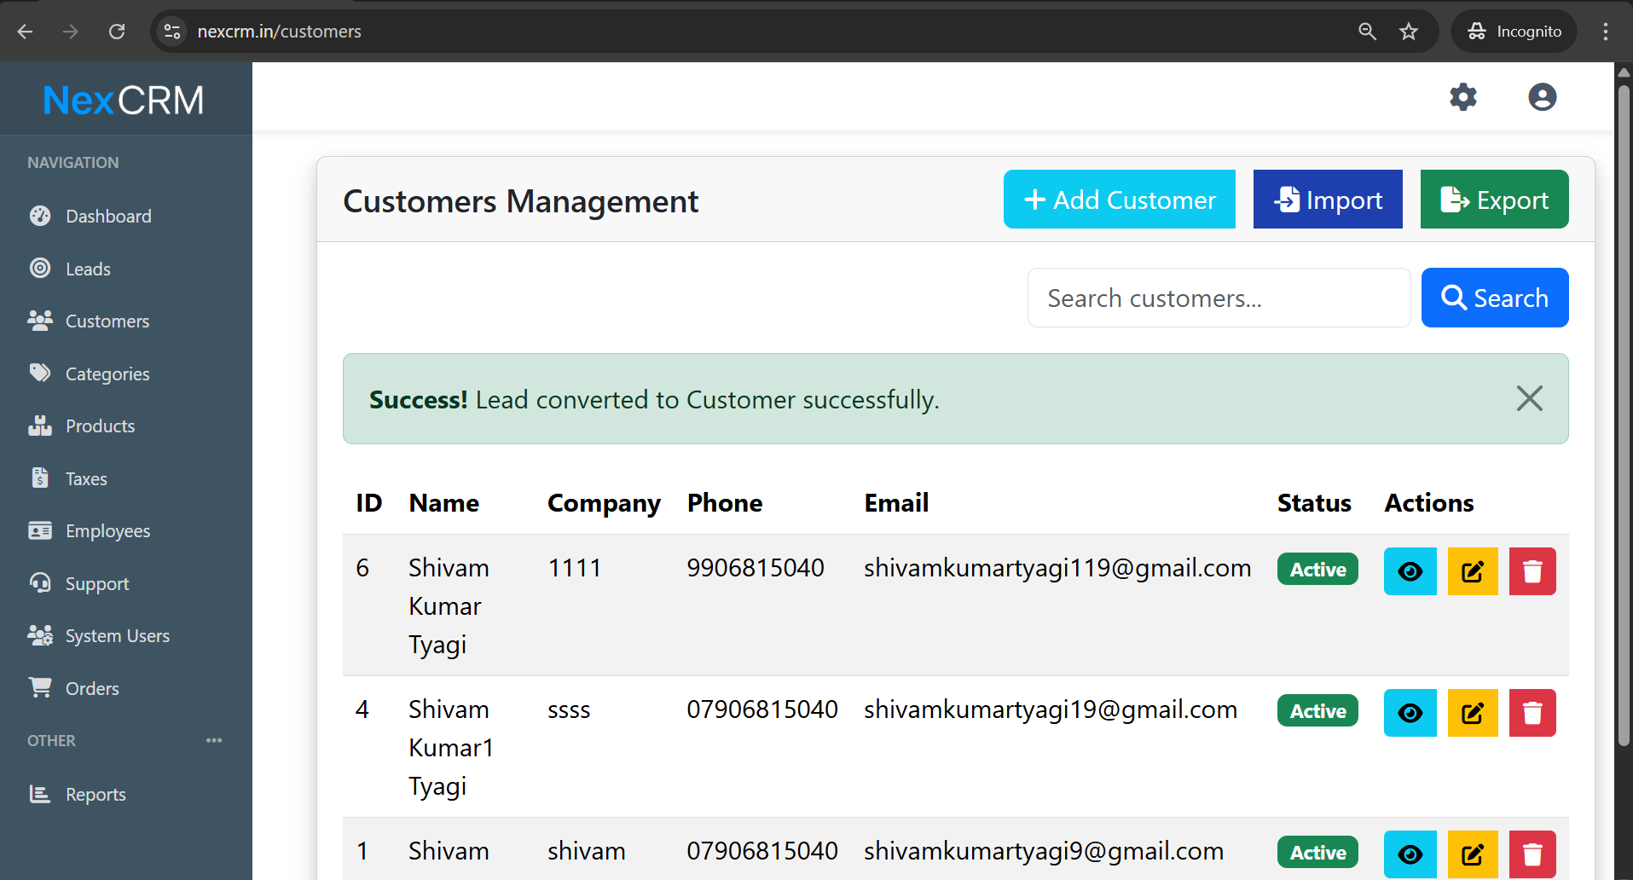

Tester comments : succefuuly convert.

Output
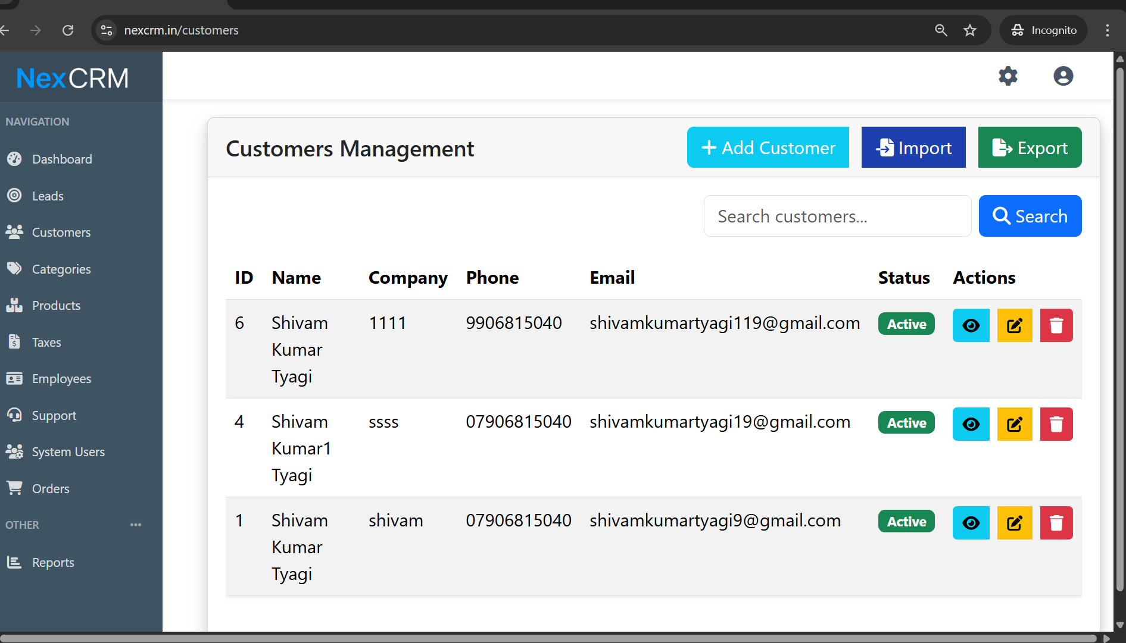

Tester comments : as we see our leads successfully convert into constumers

6.
Now check edit

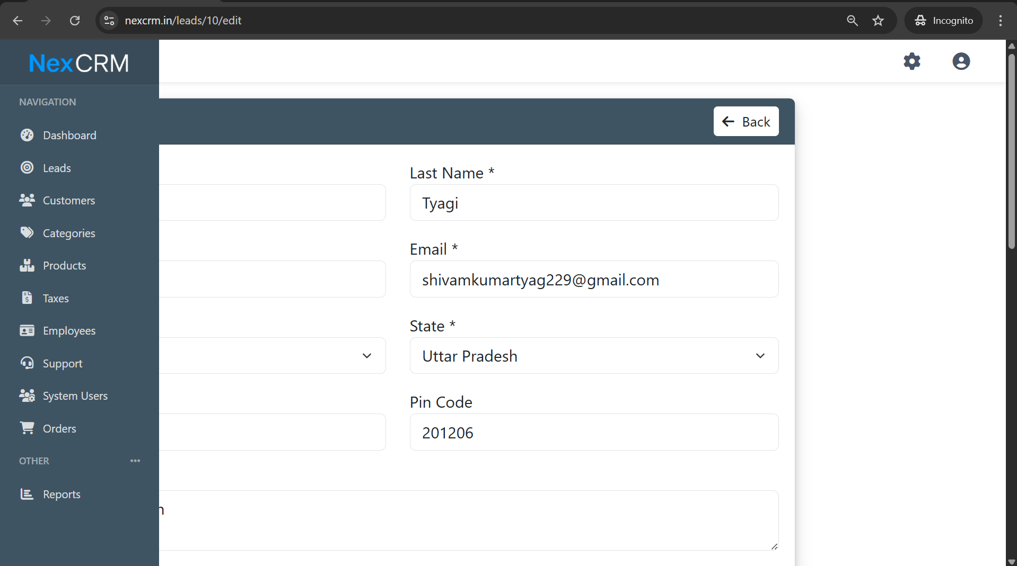

Tester comments : when we click on edit this occurs .

7.

Now check with export

Output;
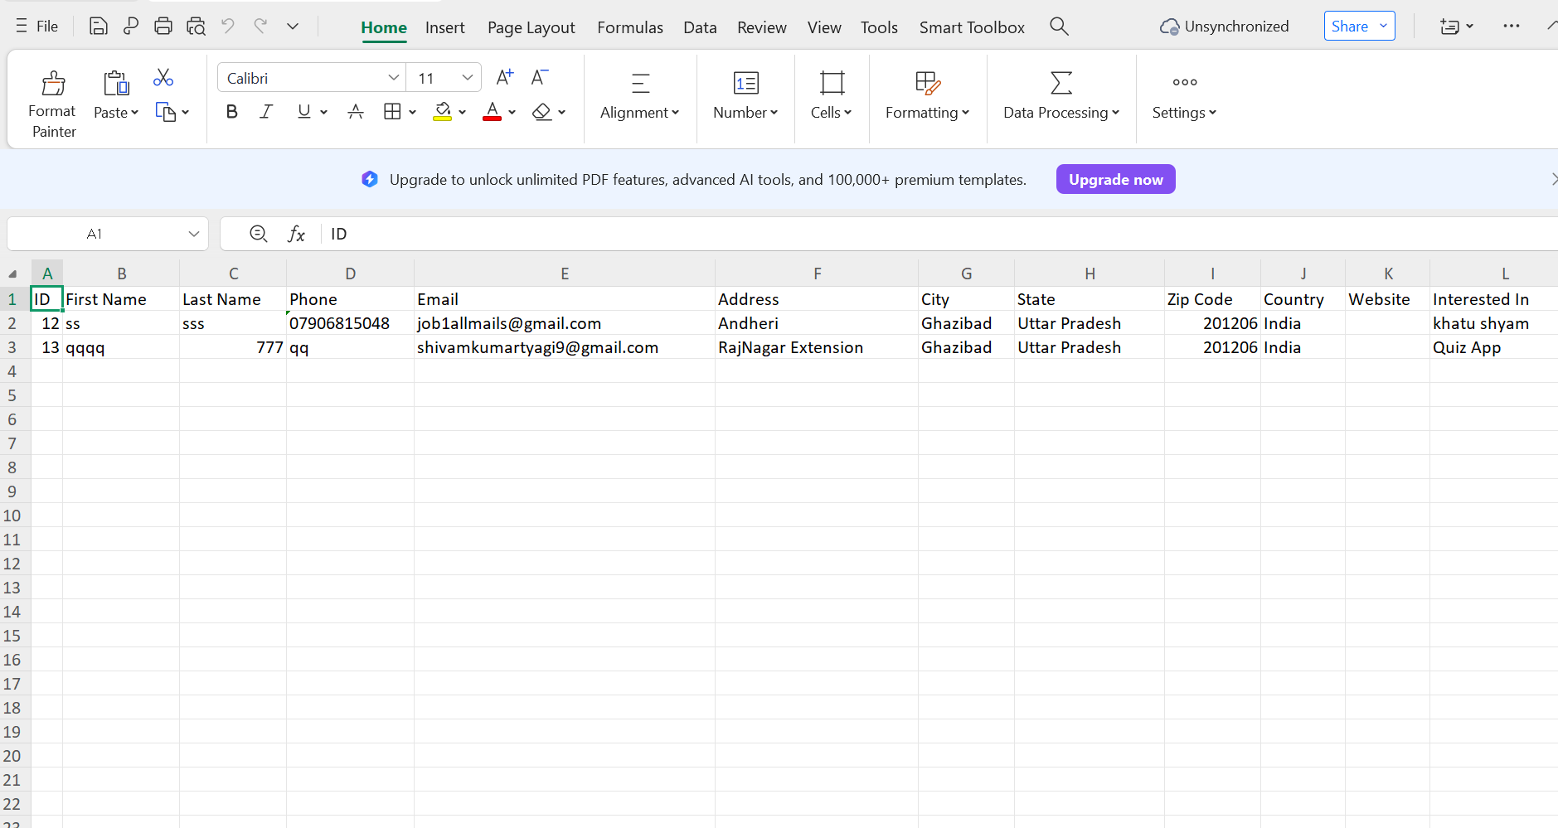

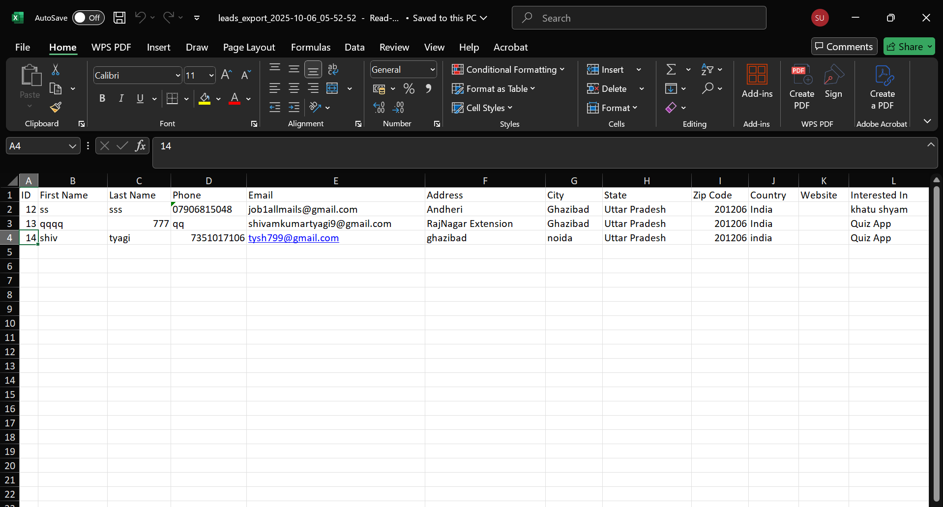

Tester comments : third line we added by ownself

Now import
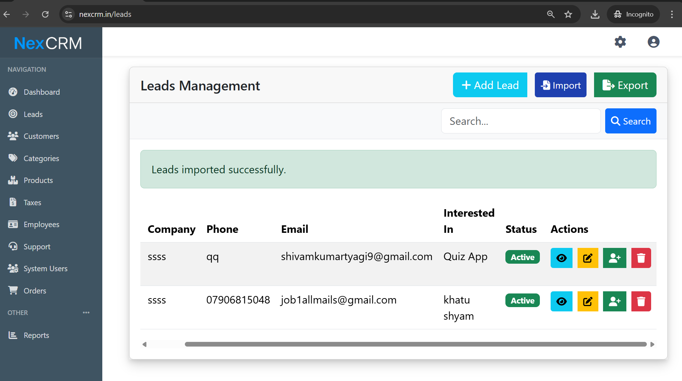

Tetser commets : lead import data not shown here with the help of excel

2.Now check customers

2.1
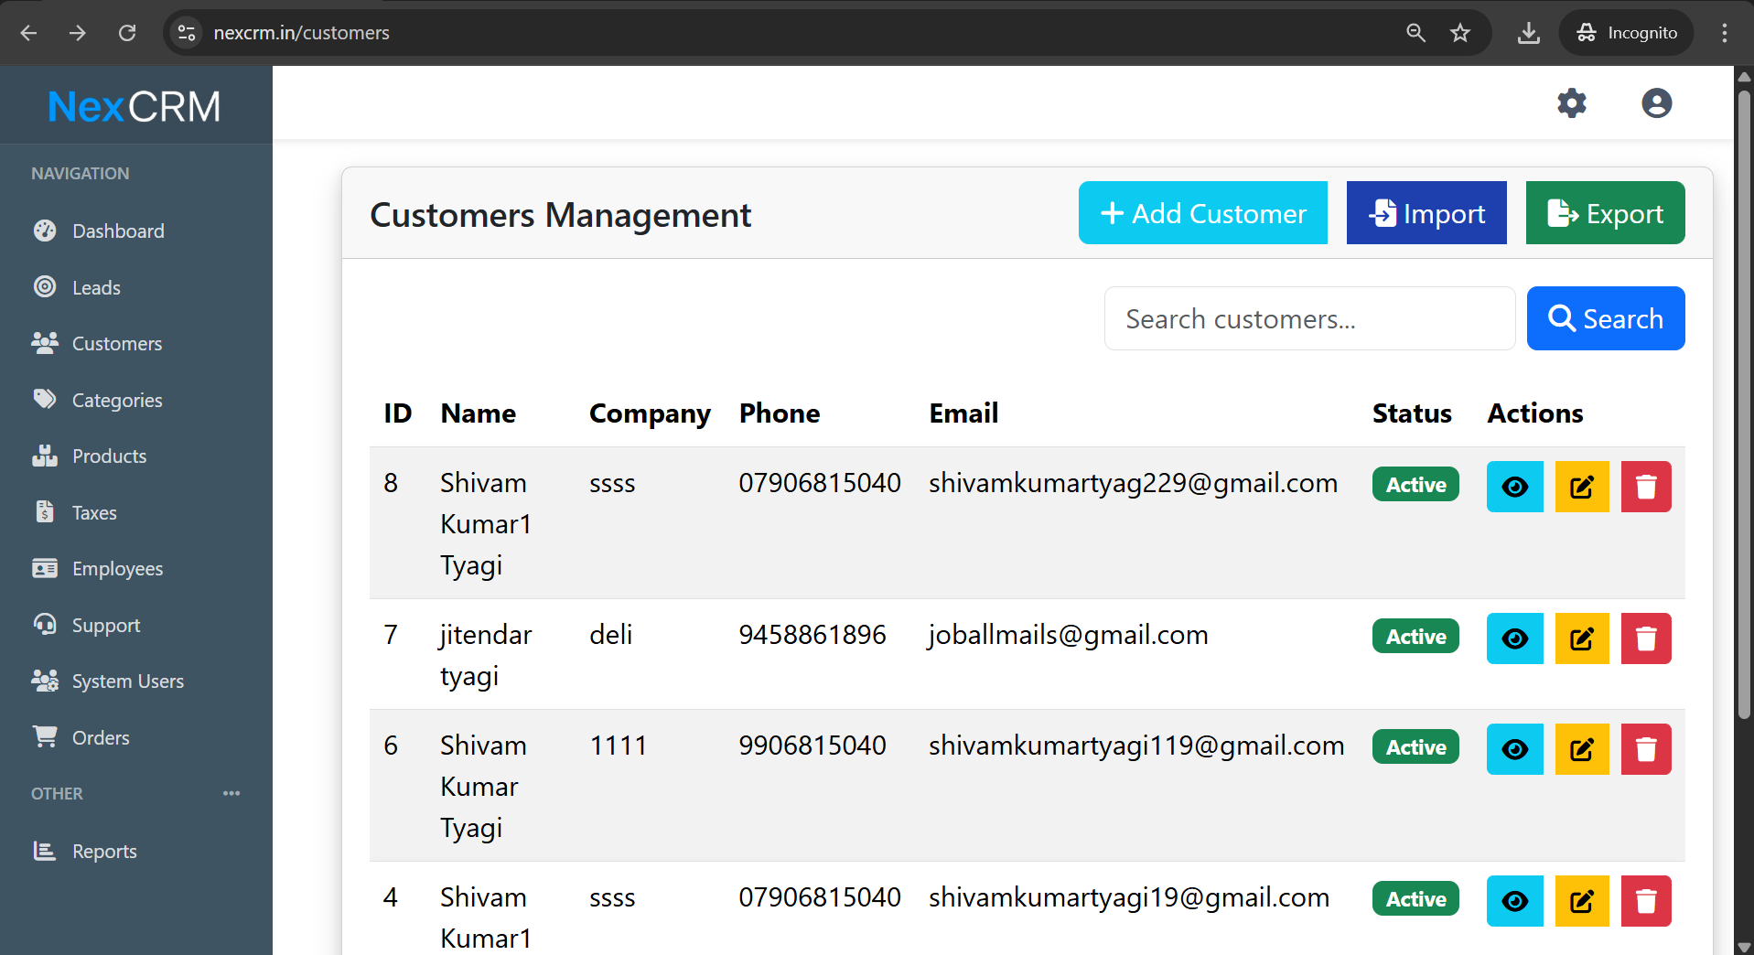

Tester comments ; this is our customer management page .’

2.2
Now click on add customer
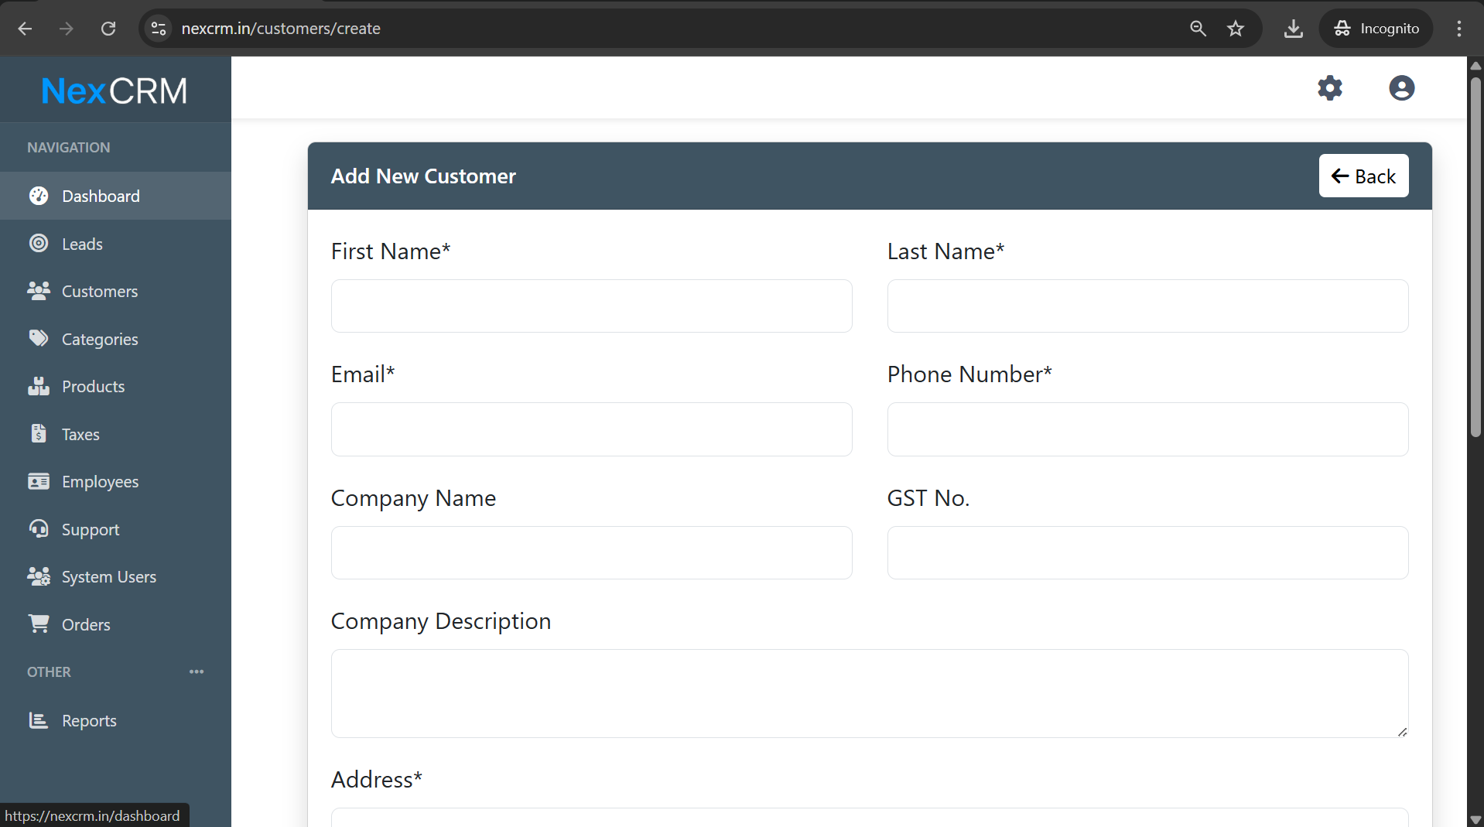Tester comments : when we click on customer this page appears.

2.3
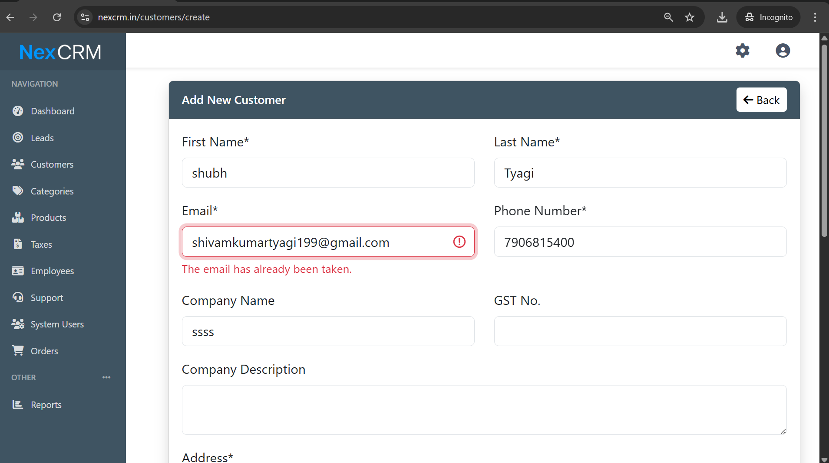

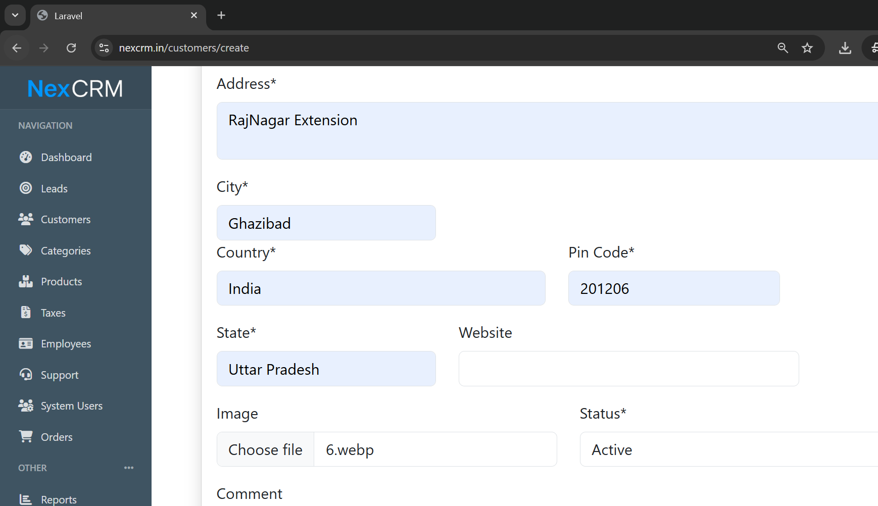

Output:
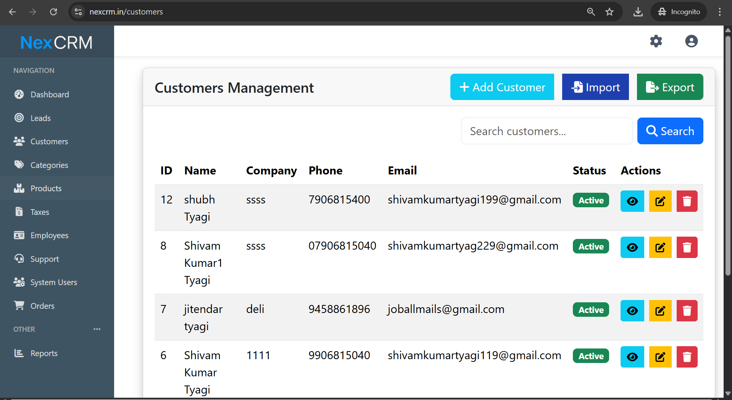

Now click on
View
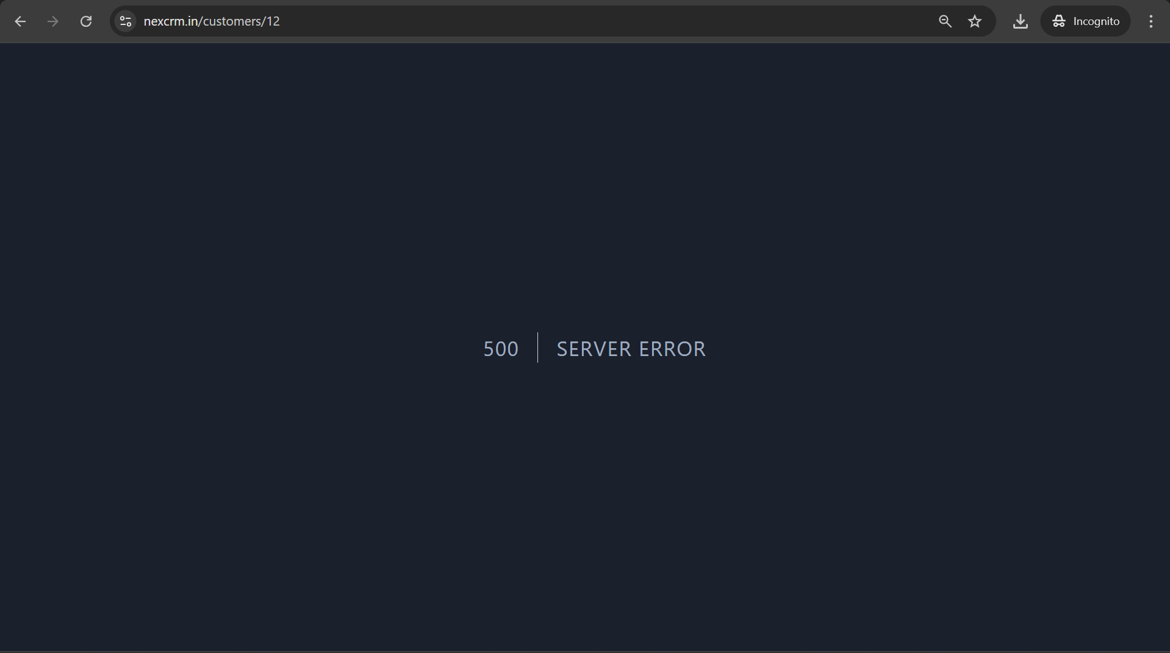

Tester comments : when we click on view this error appers .

Now click on edit
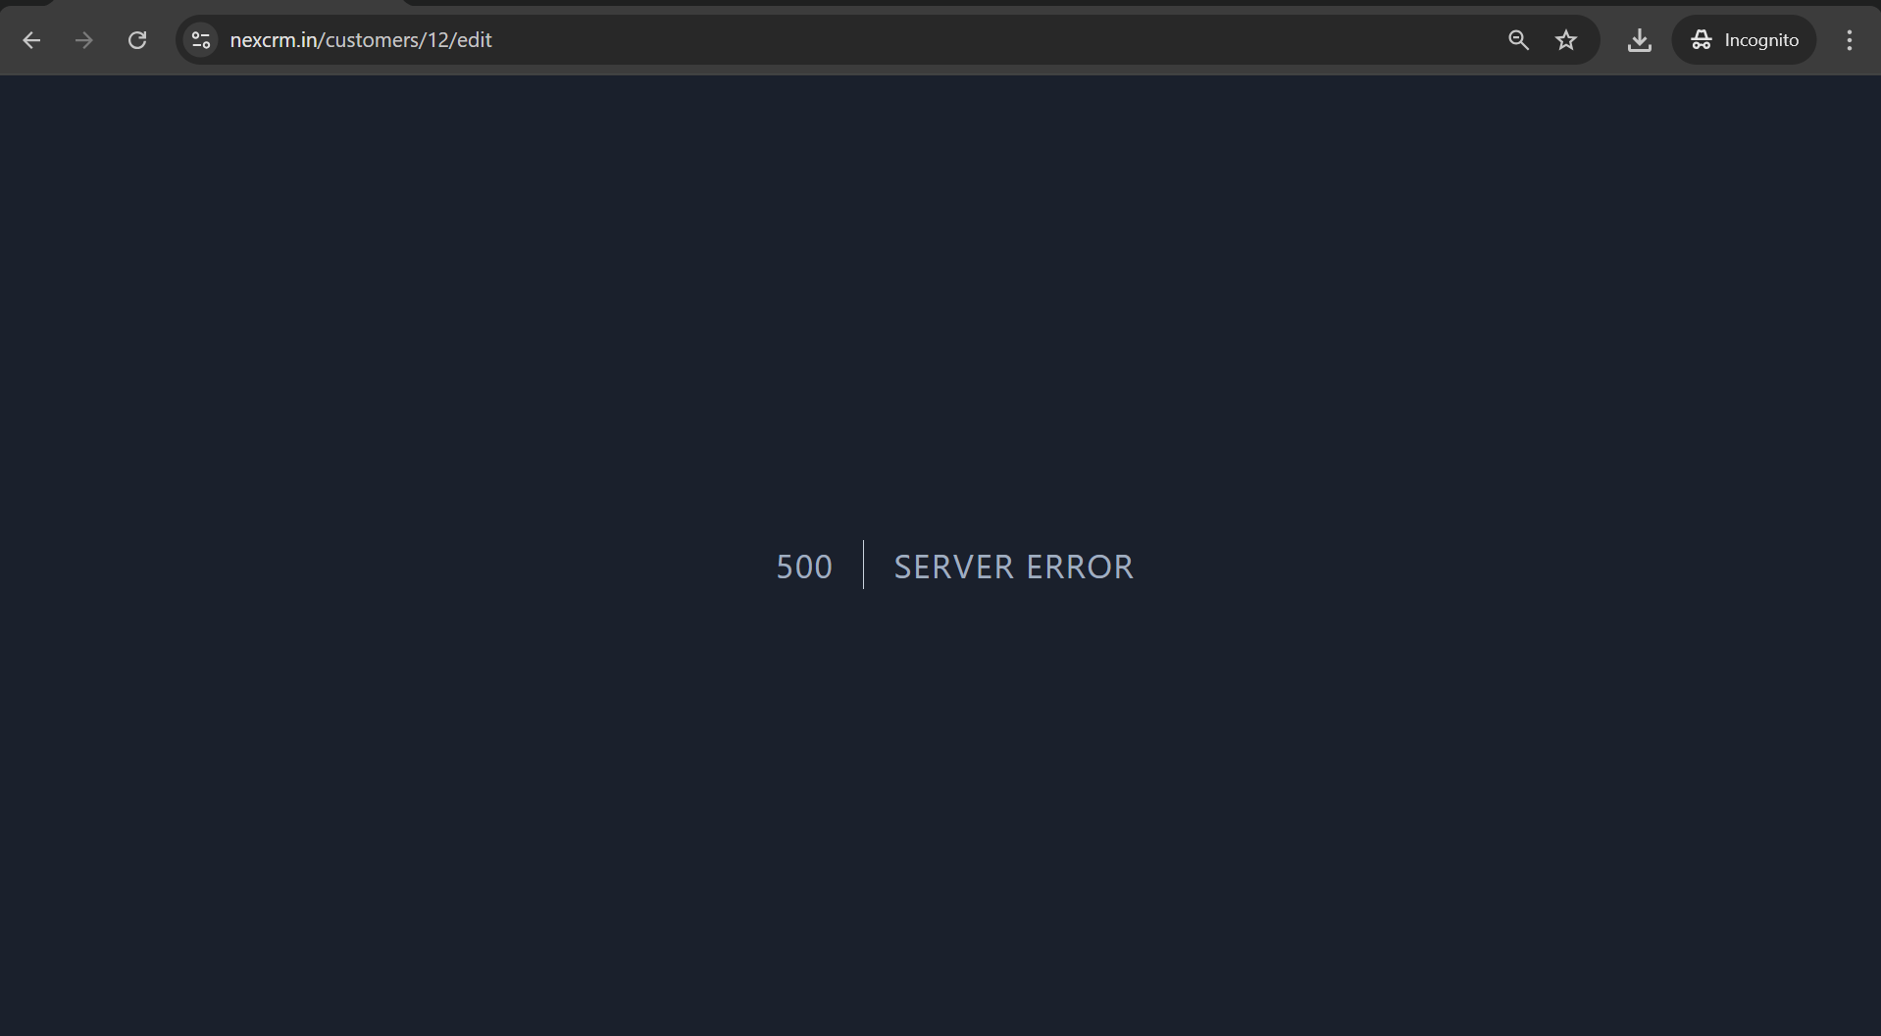

Tester comments: this bug appears 500 server error will be shown.

Now delte
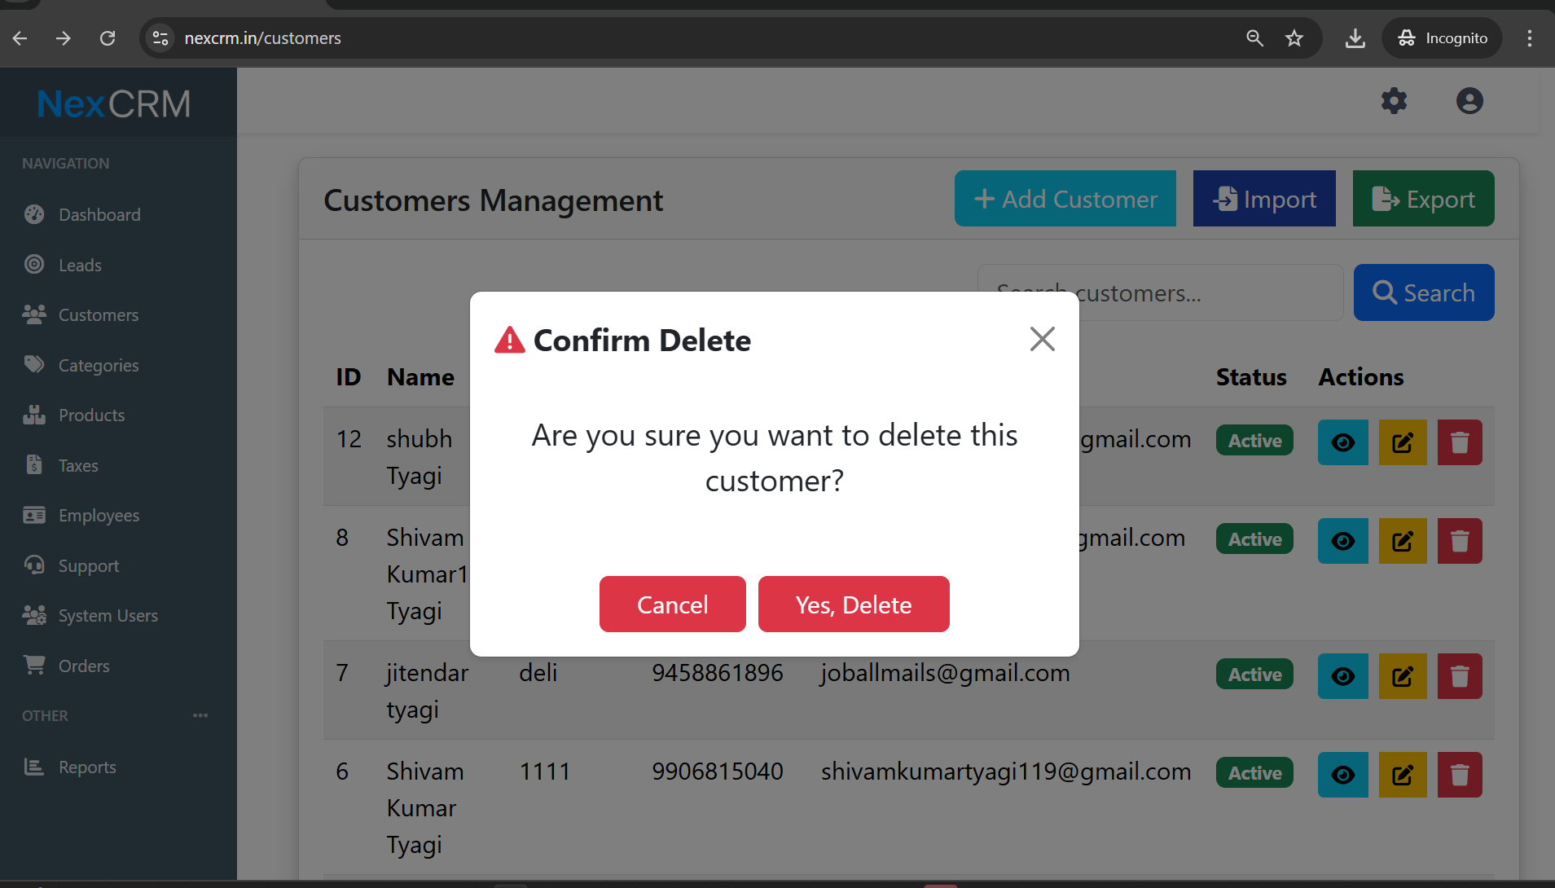

When we click on yes delete this error appers
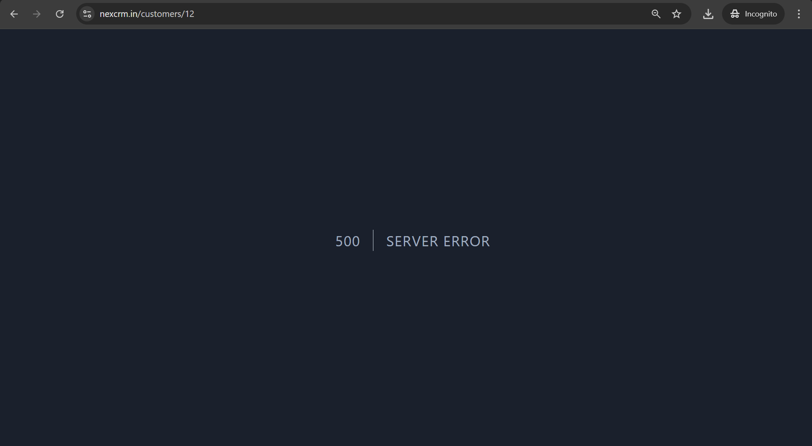

Now check with import
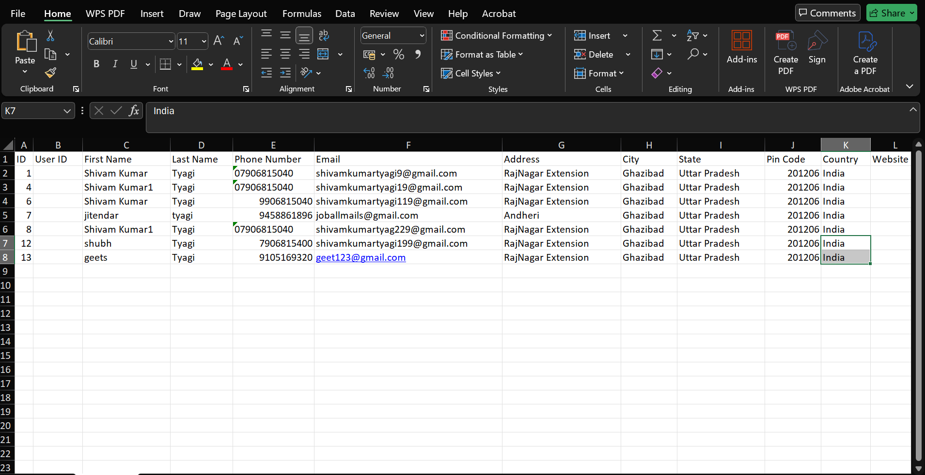

We added 13 row by ownslef

Now import
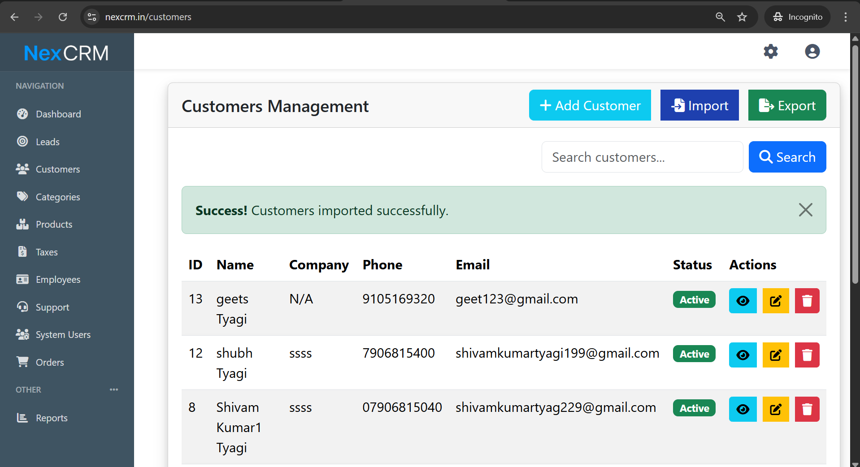

Now click on action
Viwew
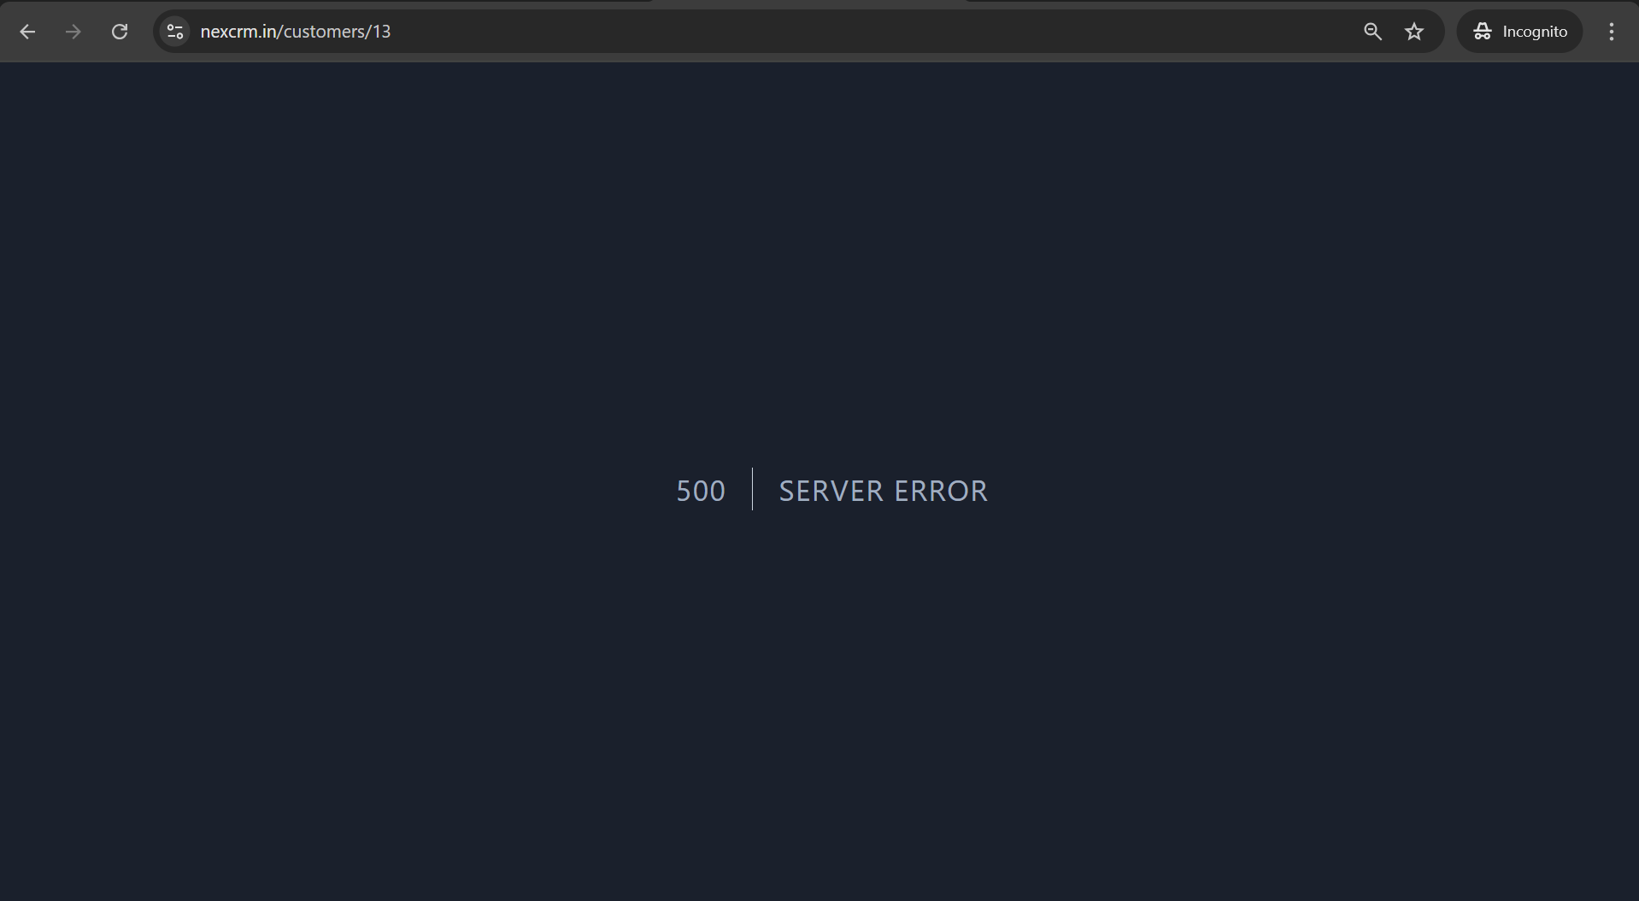

Edit

Delete

